Database Design – Powerstation Scenario
https://dd-a02.knightstone.io - working example

Before you start
When building JOINS remember to look for the foreign keys and tackle them one join at a time.
When building queries for the parts listed below you will be given the column_name aliases to use. This is because the php code uses the aliases you will be proved with.

Prepare the database
You will need to create a database called "SAD" and import the supplied SQL files found in the sql_data directory. Finally using the graph below you need to create the table called "work_schedule" and build the connections depicted (foreign keys):
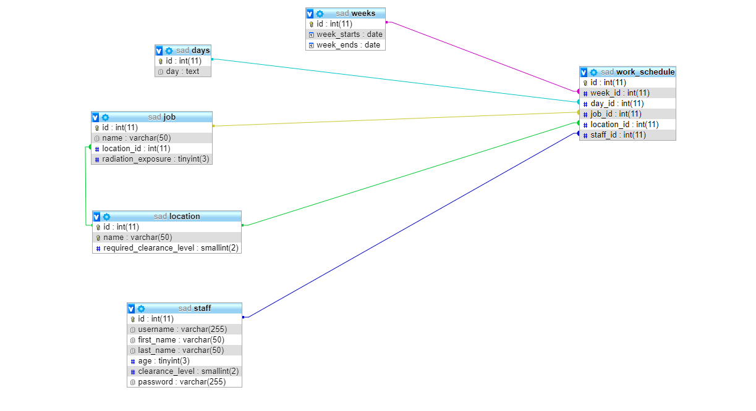

Prepare the system
Part 1: _connect.php line 6 Make sure this file can connect to the SAD database.

Enable the login system
Part 2: _auth.php line 23 You need to use $username and $password from above to find a matching staff member.

Activate the admin system
Part 3: utlis.php line 17 Starting from work_schedule, use JOINS to gather the required data from:
- work_schedule
- staff
- job
- location
You will need to use the php variables $week and $day in your WHERE clause to ensure you collect the appropriate data.

Part 4: staff_raditaion_exposure.php line 37 Starting from work_schedule, use JOINS to gather the required data from:
- staff
- job
The query will need to calculate (SUM) the total amount of radiation exposure staff members are exposed to. The query requires JOINS and it is a good idea to start from the work_schedule table
You are supplied with the WHERE clause stored within a php variable $staff_check, you will NEED to use this in you your query.
You will also need to GROUP BY staff.id
Ordering by exposure levels would be nice touch :)

Part 5: delete_work_schedule.php line 11 Create a SQL query that can DELETE a work_schedule entry based on the php variable $id

Part 6: utils.php line 120 Create a query to SELECT the listed data from the staff table.

Part 7: utils.php line 138 Create a query to SELECT the listed data from the job and location tables, you will need to use JOINS.

Part 8: utils.php line 163 Create a query to SELECT the listed data from weeks.

Part 9: utils.php line 178 Create a query to SELECT the listed data from days.

Part 10: appoint_job.php line 21 You need to create an INSERT query here to create a new work_schedule based on the provided php variables:
- $work_week_id
- $work_day_id
- $work_staff_id
To acquire the location_id you will need to create a nested SELECT query using the php variable $work_job_id.

Part 11: edit_job_appointment.php line 19 You need to create an UPDATE query here to edit a work_schedule based on the provided php variables:
- $work_week_id
- $work_day_id
- $work_staff_id
To acquire the location_id you will need to create a nested SELECT query using the php variable $work_job_id.
Make sure you use the $appointment_id from line 8 in your WHERE clause.

Part 12: utils.php line 191 Create a query to SELECT a work_schedule entry based on the id. Make sure to use the php variable $id in the WHERE clause.
-----------____
Part 13: staff_schedule.php line 11 Make sure you use $staff_id variable in your WHERE clause to SELECT staff member based on ID and select the required data.

Part 14: staff_schedule.php line 35 Starting from work_schedule, use JOINS to gather the required data from:
- work_schedule
- staff
- job
- location
- weeks
- days
You will need to use the php variable $staff_id and $day in your WHERE clause to select WHERE staff.id = '$staff_id'

